INTRODUCTION

This practice guide outlines various consultative and participative practices when working with children and young people. It is a working document and additions will be made. The activities outlined are only a snap shot of the types of activities that can be run with and by children and young people.

The colour key chart used is by no means set in stone. You know the skills and abilities of the children and young people you work with so please adapt as you see fit.

If you would like to get in contact with us about Participation in Blackpool or about the guide itself please contact us at:

Blackpool’s Access & Participation Unit
2-8 Market Street
Blackpool
FY1 1ET
01253 754841

www.rubothered.co.uk

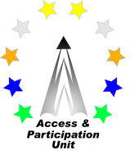

WHY DO WE INVOLVE CHILDREN AND YOUNG PEOPLE?

Benefits for children and young people

Better services for young people
Learn new skills & gain experiences
Develop confidence & self-esteem
Influence decisions that affect their lives
Develop social networks

Feel valued & empowered
Learn about democracy
Raise aspirations

Benefits for organisations

Better targeted services
Services are more accessible so more efficient
Saves money
Fresh new ideas
Credibility with young people

Happy customers
Development of children & young people’s skills

Benefits for the community

Engaged, community minded young people

A more vibrant local democracy
Better preparation of children & young people for employment

Participation in decision-making is the right of all children and young people regardless of age, gender, disability, race, religion or sexual orientation. Different children and children of different ages need to be able to participate in different ways and to different degrees. Adults need to acknowledge the need to adapt their ways of working to meet the needs of the children & young people they are working with.

HOW DO WE INVOLVE CHILDREN AND YOUNG PEOPLE?

Key to age groups:
0-5

6-10

11-15

16-19

Learning

Needs

Physical
Needs

Internet/Message Boards/Forums

If you have a website for your organisation it may be a useful
to set up a children & young people’s message board or forum to
give them the opportunity to post their views and ideas on. It would
also enable you to consult with large numbers of children & young
people on particular issues.

Newspaper/Magazine Articles

Ask young people to bring in articles from newspapers, books
or magazines to generate discussions or highlight issues they want to change. You could also ask them to write an article for your
organisations newsletter/annual report etc. so that they have a
chance to share their views.

Circle time
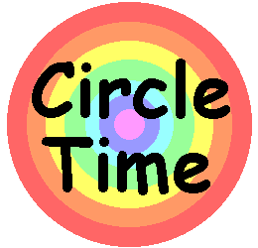
Ask the group to re-arrange their chairs so that they are in a circle facing each other. This means that eye contact is possible at all times. Decide on the topic to be discussed (or ask the group to) and use an object i.e. a ball to pass round the circle giving each person the chance
to speak. Circle Time ensures that each child or young person gets a chance to contribute and feel valued.

Tours
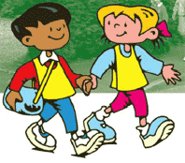
If you want to find out what children and young people think about a particular area, building, town etc. arrange to take the group on a
tour so that they can identify things they like or dislike. This gives children and young people the chance to actually visualise what they
are being asked about and is far more interesting than sitting in a
room trying to picture it.

Involve parents

This is particularly helpful when working with babies and very young children as they can only communicate by sounds, movement, actions
and signs. Parents of babies and young children know their children better than anybody else and can interpret the sounds, movements, actions and signs that their babies use.

3D modelling/Junk modelling

Collect empty boxes, containers, and other bits and pieces. Provide
children and young people with glue, sticky-tape, scissors, and encouragement. They can make anything from models of their local
park and what they want to change to a model of Blackpoll tower to represent what they like about Blackpool.

Peer interviews
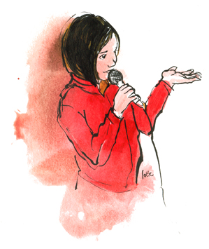
Get hold of a microphone and tape recorder and ask children &
young people to interview their friends and other groups. This is
more interesting than simply doing a questionnaire and all your
answers are recorded and accurate.

Observations

Direct observation can be useful particularly if children and young
people are unable to communicate verbally. Watching non verbal communication such as body language, eye-contact, facial
expressions or hand gestures can tell you a lot.

Photography
Giving children and young people a disposable camera to take
photographs of the things they like or dislike is a great way of
capturing children and young people’s views. Asking them to talk
about the pictures they have taken once they have been developed.

Collages
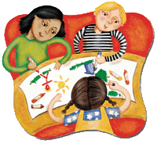
Collect magazines/newspapers etc. and ask children and young people
to make collages of their ideas, views and opinions. These are a nice
way of displaying, presenting young people’s work/views.

Murals/graffiti wall
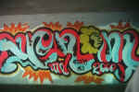
Murals and graffiti walls are a useful way of collecting a large
number of children & young people’s views on a subject. These can be added to over a period of time.

Roleplays/Senarios
This a fun way for children and young people to express their views.
and act out practical solutions.

Events/Conferences
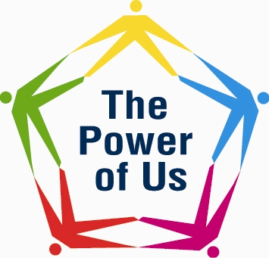
Events and conferences are a great way of getting lots of young
people together at one time and in one venue. Supporting children
and young people to design, plan and facilitate events and
conferences is a positive way of engaging and empowering them.

Making video’s
Making a video is a creative and fun way of getting children and young people involved. It’s also a great way of recording, evidencing and presenting children and young people’s work and ideas.

Board game
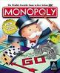
Ask the children and young people to design and produce a board
game to match the topic of discussion for example bullying.
This way you can find out the children and young people’s
Knowledge of the subject and their idea’s for solutions.

Making music
Ask children & young people to write a rap or song about a
particular issue. Try and get it recorded and produced on a CD for
them to keep as record of their achievements and to use to advise
others of their views and ideas
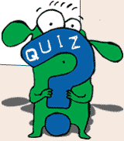
Pop quiz
A quiz is a fun way of finding out children and young people’s
knowledge on a subject.

Mind map
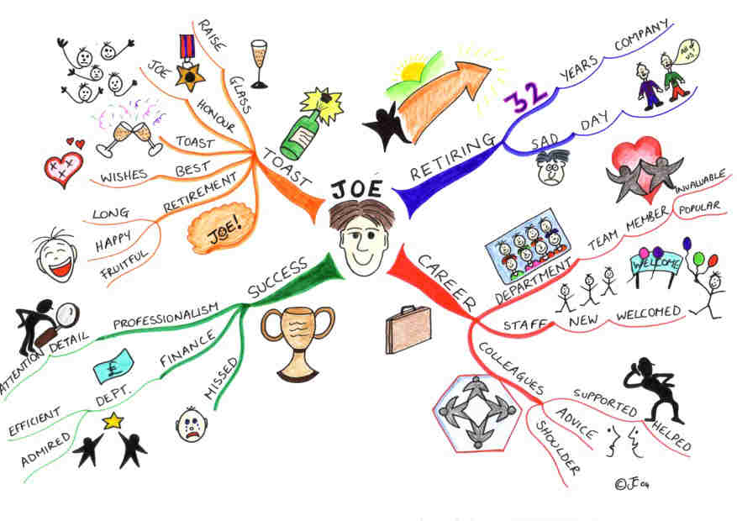
This is a good way of engaging children & young people in an activity
that will help them learn and process information about a topic. It
enables you to explore a subject and gain children & young people’s
views. It’s also a great way of harnessing children and young people’s
creativity and spontineity

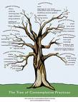
Idea’s Tree
Children & young people can create a large tree made out of
whatever they wish. They can attach their ideas and thoughts
on small paper leaves. Good for use at events/conferences.

Participation Train
The participation train works on the same basis as a steam
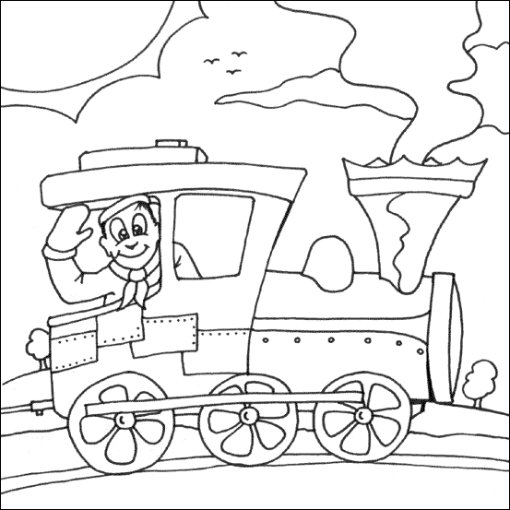
train as in different things have to happen in order for it
to work, the train is the notion of participation, the coal
equals the young peoples issues/ideas, the track highlights
the destination and what we need to do to get there and
the steam is the visible outcome.

Comments Box

Provide an accessible comments box within your organisation where children and young people can post their views and comments about
what is important to them. Make sure you provide feedback to the children & young people and use as to generate discussions.

Surgery’s
A great way to involve children & young people is to support them to
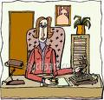
hold surgeries for their peers. This would involve arranging a set time
and venue where young volunteers can be available for other young
people to come in and talk to them about issues.

LIST OF AVAILABLE RESOURCES

Blackpool’s Access & Participation Unit website: www.rubothered.co.uk

Hear By Right
Blackpool uses the National Youth Agency and Local Government Association Hear By Right Standards.
This is a self-evaluation tool to map & plan effective participation within your organisation.
The A & P unit offers support, guidance and training regarding these standards. For more information please contact the unit.

General Participation
TITLE: Young Children’s Citizenship (Ideas into practice)
AUTHOR: Carolyne Willow, Ruth Marchant, Perpetua Kirby and Bren Neale
DESCRIPTION: Explores ways in which children’s citizenship, their entitlement to recognition, respect and active participation in society can be built into everyday practices and relationships between adults and children
TITLE: Ready, steady change
AUTHOR: Children’s Rights Alliance for England
DESCRIPTION: Training & toolkit to increase children’s and young people’s effective participation in decision making
TITLE: Participation – Spice it up!
AUTHOR: Save the Children
DESCRIPTION: Practical tools for engaging children and young people in planning and consultations
TITLE: Vision Statement Workbook
AUTHOR: The Board of Parish Education
DESCRIPTION: The Vision Statement formulated from the views of Children’s Forums in congregations all round the country. Introduced as part of the Year of the Child and provide an opportunity for children to discuss topics which affect themselves and the Church locally and nationally.
TITLE: It’s Only Right!
AUTHOR: Susan Fountain
DESCRIPTION: Children around the world need to understand the concept of rights, to know what rights they are entitled to, and empathize with those whose rights have been denied, and to take action on behalf of their own rights and those of others. This is a way to begin.
TITLE: Children as Partners in Planning
AUTHOR: Lina Fajerman, Michael Jarrett & Faye Sutton
DESCRIPTION: A Training Resource to support consultation with children
TITLE: Empowering children and young people
AUTHOR: Phil Treseder
DESCRIPTION: A guide to empower children and young people by creating respect, equality for all, taking control of our own lives.
TITLE: Better results for children and families
AUTHOR: David Utting, Wendy Road, Gillian Pugh
DESCRIPTION: Involving communities in planning services based on outcomes
TITLE: Seen and Heard 2
AUTHOR: BT and UK Youth Parliament
DESCRIPTION: a reminder to decision-makers that if they listen to the views of children and young people, their service will be the better for it.

TITLE: Getting Under The Surface
AUTHOR: Ian Sparks
DESCRIPTION: The experience of workers in the children’s voluntary sector who are working to make children’s & young people’s participation into a reality. Interviews with workers and staff across many charities.
TITLE: Partners in Rights
AUTHOR: Teresa Garlake & Marian Pocock
DESCRIPTION: A pioneering arts project by Save the Children involving young people in the UK, Latin America and the Caribbean. To increase children’s understanding of the United Nations Convention on the Rights of the Child, to share experiences of rights issues and exchange skills.
TITLE: Hear by Right: Standards for the active involvement of children and young people
AUTHOR: National Youth Agency & Local Government Association
DESCRIPTION: Tried and tested standards for organisations across the statutory and voluntary sector to assess and improve practice and policy on the active involvement of children and young people.
TITLE: Taking Part toolkit: Promoting the ‘real’ participation of children and young people
AUTHOR: Nothwest Children’s Taskforce
DESCRIPTION: Toolkit to help practitioners promote the participation of children & young people
TITLE: The recruitment pack
AUTHOR: Save The Children
DESCRIPTION: Toolkit to involving children & young people in the recruitment of staff.

With disabled children & young people
TITLE: Onwards and upwards: Involving disabled children and young people in decision-making.

AUTHOR: J. Griffiths, G. Cunningham and S. Dick, Children in Scotland, 1999.
DESCRIPTION: A training manual for practitioners.

TITLE: Don't leave us out.

AUTHOR: J. Morris, 1998.
DESCRIPTION: Includes checklists for involving disabled children and young people in different contexts.

TITLE: Researching children's perspectives.

AUTHOR: Lewis and Lyndsay, 2000.
DESCRIPTION: Includes discussion about carrying out research with children with Down's syndrome and children with severe/moderate learning difficulties.

TITLE: Two-way street: Training video and handbook about communicating with disabled children and young people.

AUTHOR: NSPCC/Joseph Rowntree Foundation/Triangle, 2001

TITLE: I'll go first.

AUTHOR: L. Kirkbride, The Children's Society, 1999
DESCRIPTION: Provides practitioners with practical tools to enable disabled children to communicate their views when key decisions are being made about their care and education.

TITLE: Listen up! Helping children with a learning disability complain about the services they use.

AUTHOR: Mencap, 2003.

TILTLE: Listening as a way of life: Listening to young disabled children.

AUTHOR: M. Dickens, National Children's Bureau, June 2004.
DESCRITION: Factsheet for practitioners. Available at www.ncb.org.uk/resources/listening-disabled.pdf

TITLE: Consulting with children and young people on accessibility strategies: A good practice guide.

AUTHOR: Children in Scotland, 2003.

TITLE: Seen and heard: Involving disabled children and young people in research and development projects.

AUTHOR: L. Ward, YPS, 1997.

TITLE: Starting with choice: Inclusive strategies for consulting with young children.

AUTHOR: M. Dickens, S. Emerson and P. Gordon-Smith, Save the Children, 2004.
DESCRIPTION: Includes a range of techniques for early years workers to support disabled young children in expressing views and making choices.

With younger children

TITLE: Never too young: How young children can take responsibility and make decisions.

AUTHOR: J. Miller, National Early Years Network/Save the Children, 2003.
DESCRIPTION: Provides a range of ideas about how to involve young children and suggests appropriate methods for specific ages.

TITLE: Young children's right's: Exploring the beliefs, principles and practice.

AUTHOR: P. Alderson, Jessica Kingsley Publishers, 2000.

TITLE: Participation: Spice it up!

AUTHOR: Save the Children/Dynamix, 2002.
DESCRIPTION: Provides practical tools for engaging with children as young as 18 months.

TITLE: Listening to young children: Mosaic approach

AUTHOR: P. Lancaster, Open University Press, 2003.

DESCRIPTION: Policy makers, practitioners and researchers who are engaged in searching for new theoretical, practical and imaginative ways of listening to young children. A potential tool for younger children, those with communication difficulties or for whom English is a second language.

TITLE: Spaces to play: More listening using the Mosaic approach.

AUTHOR: Alison Clarke & Peter Moss (NCB)

DESCRIPTION: Following on from `Listening to Young Children: The Mosaic approach' (NCB, 2001), this book reports on a pilot study that used the Mosaic approach to explore with young children their understandings and uses of outdoor provision, in order to inform future plans.

TITLE: Primary RE

AUTHOR: The RE Today Professional Services Team

DESCRIPTION: Development of many ideas and materials, in this way DfES has supported the work of PcfRE to enable primary teachers to approach the relationship between RE, PSHE and Citizenship positively.

TITLE: Young children's citizenship: Ideas into practice.

AUTHOR: B. Neale (ed), Joseph Rowntree Foundation, 2004.

TITLE: I can, You can, We can

AUTHOR: Hilary Keating

DESCRIPTION: I Can, you can, we can is the result of an extensive project developed in Knowsley through Surestart and Knowsley Borough Council Arts service. A rhyming picture book full of activities and ideas to enjoy and have fun with younger children by giving them choices and listening to their decisions.

TITLE: Never too Young

AUTHOR: Judy Miller

DESCRIPTION: How young children can take responsibility and make decisions, a handbook for early years workers

TITLE: Beyond Listening: children’s perspectives on early childhood services

AUTHOR: Alsion Clark, Anne Trine Kjorholt & peter Moss

DESCRIPTION: The first book of its kind to focus on listening to young children both from an international perspective and through combining theory, practice and reflection. Has contributions from six countries, and each chapter is rooted in the everyday lives of young children, and presents a range of actual experiences.

