 Going for growth resource sheets

This prayer idea could be used by families, children’s groups or in all-age worship. It has been adapted from an original idea by Kurt Focht from Valley View Community Church, Philadelphia USA posted on the EngageWorship website.

PRAYING HANDS

You will need:
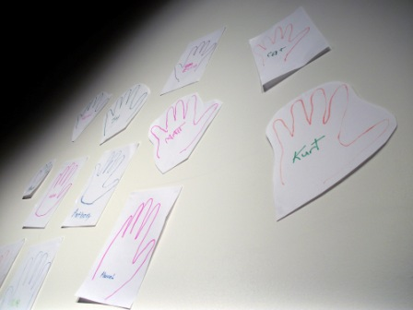
- Coloured markers or crayons
- A5 sheets of paper
- Scissors
- Blutack or sticky tape
What to do
- Invite people to trace round their hand on an A5 size sheet of paper and write their name in the middle of the hand.
- Suggest that they might like to add one word or picture that describes what they would like prayer for.
- Roughly cut out the hand (optional).

How to use the praying hands at home
Fix the hands close to the front door. Encourage people to touch the hands as they pass by and pray for the person concerned.

How to use the praying hands in children’s groups
Attach the hands to the walls in the room where you meet. Encourage the children to move around and place their hand against one of the paper hands. As they do so, suggest that they pray quietly for that person. Leaders should take part in this and not just be on-lookers.

How to use the praying hands in worship
Create the praying hands either as people arrive for worship (have the paper and pens ready on a table) or as part of the Intercessions. Fix them to the walls of your worship area. Invite people to move around the church and either stand in front of a hand, or place their hand on one of the outlines and pray for the person named on it.

