 Going for growth resource sheets

Carolyn C Brown offers ideas to help explore the concept of Trinity with children and to open up the Bible readings for Trinity Sunday. Taken from her website http://www.worshipingwithchildren.blogspot.com

TRINITY SUNDAY Year A

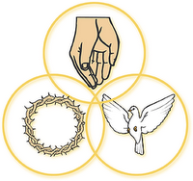
Intersecting circles
forming triangle in middle

Trinity Sunday calls us in two slightly different directions. It is an opportunity to tell the children about the trinity which is often referred to in worship, but seldom explained. Fairly simple introductions of the Trinity and highlighting its use in worship helps. But, Trinity Sunday is also really “God Sunday,” an opportunity to celebrate the mystery of God that is more than we ever fully understand. Both are important to children.

 Introduce the trinity. Most children know “God and Jesus,” but fewer hear much about the Holy Spirit – unless they heard the word during Pentecost celebrations last week. So the task is to add the Holy Spirit and to tie all three together. One way to begin is with trinity images. Point to trinity images in your worship space and/or show one or more of these images. Identify the three separate parts that are bound together, e.g. each leaf of the clover is a leaf and only together are they a clover. Name the three persons and briefly mention things we know about each one. Early in the service challenge worshippers to be alert for “father, son, and holy spirit” in your songs, prayers, and stories today.

﻿ If you regularly use musical congregational responses that name the trinity (The Doxology, Gloria Patri), interrupt after they are sung today. Ask, “What did you just sing?” Then, briefly walk through the words defining difficult words and explaining the meaning of the whole song as sung where it is. Then, invite the congregation to sing it again. (Do warn the musicians of your plan.)

 Celebrate God who is more than we ever understand. Many children assume that the adults all know everything there is to know about everything – including God. If during their childhood they are told repeatedly that this is not true, when they begin asking important questions about God they will know they are not being outrageous, but doing what everyone does and has done for years. That makes a big difference. So, today celebrate both what we know about God and the God who is more than we can ever understand. The Roman Catholic lectionary for the day offers God’s name, “I am who I am, I will be who I will be,” from the burning bush as the Old Testament reading for the day. Today is a good opportunity to ponder that name.

It is also a good day to cite the unanswerable questions people of all ages ask about God, such as but definitely not limited to:

- What was God doing before God created the world?
- How can there never be a time before or after God?
- How can God pay attention to each person in the world all the time?
- Why did God create rattlesnakes and mosquitoes?

 If there is a conversational time with children, gather “I wonders” about God. Begin by telling some of the things you wonder about. Invite them to tell some of the things they wonder about. Be sure all worshippers knows that no honest “I wonder” is too funny or too bad to be pondered.

 To explore the fact that our understanding of God changes and grows, share some of your “used to thinks” about God and tell what you now think and how the change occurred. For example, I used to think God was a man but now think God is neither a man nor a woman. Also, express the expectation that what you now think may become a “used to think” in the future. (This could be done in a children’s time, but if it is done as part of the real sermon, children realize that you are talking to the adults too and expect their ideas about God to change and grow.)

 Sandy Sasso’s beautifully illustrated book In God’s Name tells that after creation all animals had names. But God did not. So, all the animals came up with their own name for God, none of which was complete without the others.

 “Immortal, Invisible, God Only Wise” is filled with long complicated words that describe God who is more than we can fully understand. If this is pointed out, children enjoy all the impossible words praising God who is impossible for us to understand. Before singing, point out and define the first few words of verse one – immortal means God lives forever, invisible means we can’t see God. Then ponder the meaning of the first phrase of verse 2 (“Unresting, unhasting and silent as light”). Finally, challenge worshipers to pay attention as they sing to what it is trying to say about God.

 “Holy, Holy, Holy” is often sung. Before singing it today, define the word holy (most special and important, awesome) and briefly walk through the verses. This helps children learn the hymn and makes all worshipers pay better attention to what they are singing.
1. We praise God
2. Everyone in heaven praises God
3. Even though we do not fully understand God, we praise God
4. Everyone and everything on earth praises God

Genesis 1:1 – 2:4a

 In advance, ask the children to help you create a processional reading of this scripture. Ask them to prepare large poster board illustrations of things God made and to mount them on dowels. As the accounts of the days are read, children carry in the posters for that day down the central aisle. At the conclusion of the day, those children say, “And there was evening and morning, the first/second…. day.” Children remain at the front until the entire week is read. This could be done by as few as six children or by as many as are available and fit in the space. With fewer children the last day’s posters could include pictures of many kinds of critters. If there will be lots of children, each child may make a poster of a single critter of their choosing. Singing a creation hymn immediately following this processional reading gives the children time to return to their seats.

Day 1: day and night (blank black and yellow shapes)

Day 2: the sky (sky blue shape – with a rainbow if someone insists)

Day 3: division of land and seas (big planet earth) and creation of plants

Day 4: the sun and the moon and stars

Day 5: water creatures and birds

Day 6: animals and people

This is a project for several church classes for several weeks. One week will be needed to make the posters. One rehearsal will be needed just before the service. And, adult help getting everyone started down the aisle in correct order is essential. It is not a small effort, but both children and adults enjoy reading the familiar story this way and the children feel they are definitely part of the worshiping community.

 Give the children an In the Beginning God Created worship worksheet on which to draw pictures of each thing created on the day it was created.

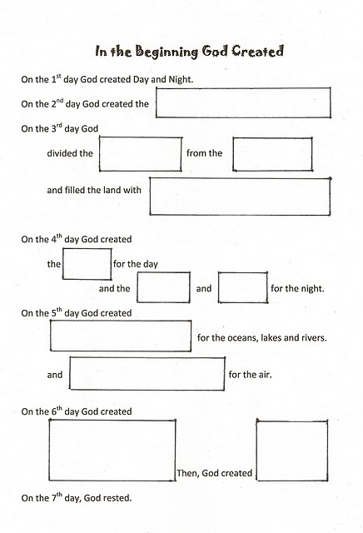

 There are several DVDs and even CDs available of James Weldon Johnson’s poem “The Creation” which retells the creation story from an African American perspective. It is also presented in a picture book: The Creation (ISBN 9780823412075).

 Pair the creation story with Psalm 8 to explore our place in the world at the beginning of summer and Ordinary Time. During summer children generally spend more time outside. Challenge them to take care of God’s world. There are lots of things they can do, e.g. not toying with or hurting the creatures and plants where they play, not leaving trash (dropped candy or gum wrappers!), leaving every place we go a little better than we found it, etc. During Ordinary Time in worship we focus on learning and growing as disciples and a church. This pair of texts tells us we are created in God’s image, said by God to be good, and are given the task of care for the world. That is a good start for Ordinary Time.

 Hymns to God the Creator that children especially enjoy:

- “All Things Bright and Beautiful” may be familiar and is filled with familiar, concrete words about creation.

- “Earth and All Stars” has a repeated chorus. Children enjoy calling on very modern things to praise God.

- “All Creatures of Our God and King” has a familiar tune, the names of lots of animals, and repeated “alleluias.”

Psalm 8

 Read from Today’s English Version which uses vocabulary children understand more readily – “Lord” instead of “Sovereign,” “greatness” instead of “majesty,” and the moon and stars that you “made” rather than “established.” Most adults will not notice the difference, but the children will.

 To explore our relationship with God and our place in the world, read “Partners,” a Midrash about the creation story in which God introduces people to their role as God’s partners. The final definition of partner is “…someone you work with on a big thing that neither of you can do alone. If you have a partner, it means that you can never give up, because your partner is depending on you….” Find this two page story (read aloud in 3 minutes) in Does God Have A Big Toe? By Marc Gellman.

2 Corinthians 13:11-13

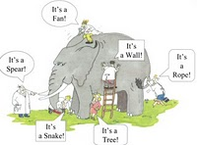
 Paul concludes his letter to the Corinthians who tended to fight with each other about almost anything, “agree with one another, live in peace.” That is good advice on Trinity Sunday when we celebrate the mystery of God. The blind men exploring the elephant story fits well here. If those blind men talked to each other about what each one had learned about the elephant rather than fight insisting that only what they knew about the elephant was true, they would learn a lot more. Likewise if we talk about all the different things we know about God, we will learn more about God than we will insisting that only what we know is true.

 Use verse 13 just before the benediction to do a little worship education. Note that Paul ends this letter with the same words we often use at the end of a worship service. Read the verse, then put it into your own words. My version would be:

May Jesus Christ who forgives us,
God who created us and loves us even when we don’t love ourselves, and the Holy Spirit who is with us always
helping us and caring for the world through us
be with you all today and every day.

As you do, define any words you traditionally use, e.g. the communion of the Holy Spirit. (Children hear communion as a reference to the sacrament and miss the intended meaning of the phrase.) Finally, offer the benediction as you generally say it so that worshipers will hear it with fuller understanding.

Matthew 28:16-20

 On Trinity Sunday point out that we are baptised in the name of the Father, Son, and Holy Spirit. Invite the children to meet you at the font. Using a doll or a person, demonstrate the use of water and say just the words that are said as the water is used. (Do not get bogged down in all the words that lead up to “the event.”) Take time to explain that this means each of us belongs to God the Father, the Son and the Holy Spirit. Whether we are baptised as a baby or an adult, we don’t understand what that means when we are baptised. Actually, we spend our whole lives learning what that means and never completely figure it out. But, we still belong to God.

